

SAN-JAN DATA ANALYST AND TECH

Big data for better solution

Version *<2.0>*

*<24/11/2016>*

*Author: Janakiraman*

Table of Contents

1. Project definition 3

1.1 What is BIG DTA 3

1.2 Background 3

1.3 Business Case 3

1.4 Project objectives 3

1.5 Project Scope 4

1.6 Desired output for project 4

1.7 Project budget 4

1.8 Tools and Techniques 4

2. E-Commerce 7

2.1 What is E-Commerce 7

2.2 Databases for Transaction details 7

2.3 Databases for Customer details 7

2.4 List of use cses 8

3. Project through Mapreduce 9

4. Project through Hive 13

5. Project through Pig 15

6. Software and Hardware Requirement 19

7. Conclusion 19

**Project Definition**

* 1. **what is BIG DATA**

Big data is a term that describes the large volume of data – both structured and unstructured – that inundates a business on a day-to-day basis. But it’s not the amount of data that’s important. It’s what organizations do with the data that matters. Big data can be analysed for insights that lead to better decisions and strategic business moves. Big data is changing the way people within organizations work together. It is creating a culture in which business and IT leaders must join forces to realize value from all data. Insights from big data can enable all employees to make better decisions—deepening customer engagement, optimizing operations, preventing threats and fraud, and capitalizing on new sources of revenue. But escalating demand for insights requires a fundamentally new approach to architecture, tools and practices.

* 1. **Background**

San-Jan Data Analyst and Tech is a MNC (Multi National Company) for data analysis and to provide technology solution to the major industries. We uses various scenarios in Big Data to provide desired outcomes.

We are provide accurate data solution to the industries who`s generating huge amount data, using various tools and techniques under Big Data technology.

**1.3 Business Case**

Huge amount of data being generated by everything around us at all times. Every digital process and social media exchange produces it. Industries struggling with handle this amount of data. So we made it as a business to give accurate data solution.

**1.4 Project objectives**

Here our current project fully based on E-Commerce, there are tons of transaction process, log files and feedback files created. All Industries struggling to handle these huge volume of data generated by the customers. This project specifically for provide clean data solution about E-Commerce.

**1.5 Project scope**

Our E-Commerce project scope to provide clear outcomes as per the client`s requirement.

**1.6 Desired output for project**

Our project outputs comes with clear scenarios like different use cases, conditions and filtration that has applied on each phases. So it should be clear vision about what client expected.

**1.7 Project budget**

We offer less charge depend with volume of data, and for this particular E-Commerce project our offer is very flexible charge for clients.

**1.8 Tools and Techniques**

Various complex tools and mind crashing techniques we applied for this project are…

1.8.1 Hadoop Framework

1.8.2 Hive

1.8.3 Pig

**1.8.1 Hadoop Framework**

The Apache Hadoop software library is a framework that allows for the distributed processing of large data sets across clusters of computers using simple programming models. It is designed to scale up from single servers to thousands of machines, each offering local computation and storage. Rather than rely on hardware to deliver high-availability, the library itself is designed to detect and handle failures at the application layer, so delivering a highly-available service on top of a cluster of computers, each of which may be prone to failures.

The project includes these modules:

**Hadoop Common**: The common utilities that support the other Hadoop modules.

**Hadoop Distributed File System (HDFS™)**: A distributed file system that provides high-throughput access to application data.

**Hadoop YARN**: A framework for job scheduling and cluster resource management.

**Hadoop MapReduce**: A YARN-based system for parallel processing of large data sets.

**benefits**

Some of the reasons organizations use Hadoop is its’ ability to store, manage and analyse vast amounts of structured and unstructured data quickly, reliably, flexibly and at low-cost.

**Scalability and Performance** – distributed processing of data local to each node in a cluster enables Hadoop to store, manage, process and analyse data at petabyte scale.

**Reliability**– large computing clusters are prone to failure of individual nodes in the cluster. Hadoop is fundamentally resilient – when a node fails processing is re-directed to the remaining nodes in the cluster and data is automatically re-replicated in preparation for future node failures.

**Flexibility**– unlike traditional relational database management systems, you don’t have to create structured schemas before storing data. You can store data in any format, including semi-structured or unstructured formats, and then parse and apply schema to the data when read.

**Low Cost**– unlike proprietary software, Hadoop is open source and runs on low-cost commodity hardware.

**1.8.2 Hive**

The Apache Hive data warehouse software facilitates reading, writing, and managing large datasets residing in distributed storage using SQL. Structure can be projected onto data already in storage. A command line tool and JDBC driver are provided to connect users to Hive.

**Benefits**

**Time**-It take very less time to write Hive Query compared to Map Reduce code. For example, the word count problem which takes around 50 lines of code can be written in 5 lines in Hive. So, you save time.

**Easy**-It is very easy to write query involving joins (if there are few joins) in Hive.

**Maintenance**-It has very low maintenance and is very simple to learn & use (low learning curve).

**1.8.3 Pig**

**Apache Pig** is a platform for analysing large data sets that consists of a high-level language for expressing data analysis programs, coupled with infrastructure for evaluating these programs. The salient property of Pig programs is that their structure is amenable to substantial parallelization, which in turns enables them to handle very large data sets.

**Benefits**

**Ease of programming.** It is trivial to achieve parallel execution of simple, "embarrassingly parallel" data analysis tasks

**Optimization opportunities.** The way in which tasks are encoded permits the system to optimize their execution automatically, allowing the user to focus on semantics rather than efficiency.

**Extensibility.** Users can create their own functions to do special-purpose processing.

**E-Commerce**

**2.1 What is E-Commerce?**

E-commerce (electronic commerce or EC) is the buying and selling of goods and services, or the transmitting of funds or data, over an electronic network, primarily the internet. These business transactions occur either as business-to-business, business-to-consumer, consumer-to-consumer or consumer-to-business.

**2.2 Database for Transaction details**

Here is the transaction database for example.

|  |  |  |  |  |  |  |  |  |
| --- | --- | --- | --- | --- | --- | --- | --- | --- |
| Tid | Date | Cust id | Amount | Category | Product | City | State | Payment mode |
| 00000001 | 06-26-2015 | 4007024 | 040.33 | Exercise & Fitness | Cardio Machine Accessories | Clarksville | Tennessee | credit |
| 00000002 | 06-26-2015 | 4007023 | 238 | Gymnastics | Gymnastics Rings | Des Moines | Iowa | credit |
| 00000005 | 06-26-2015 | 4007028 | 1265 | Outdoor Recreation | Camping & Backpacking & Hiking | Chicago | Illinois | credit |

**2.3 Database for Customer details**

Here is the customer database for example.

|  |  |  |  |  |
| --- | --- | --- | --- | --- |
| Custid | Fname | Lname | Age | Profession |
| 4000001 | Sunitha | Devi | 22 | Teacher |
| 4000002 | Arul | Selvan | 25 | mentor |
| 4000003 | Vinod | Kumar | 33 | manager |

**2.4 List of use cases**

* Find all the transaction where amt>160.
* Count all the transaction where amount is between 175-200.
* Calculate the total sum and total count of all the transaction for each user id.
* Calculate the average transaction value for each user id.
* Calculate total sales amt for each Month.
* Divide the file into 12 files, each file containing each month of data. For eg. File 1 should contain data of January txn, file 2 should contain data of February txn.
* Find the profession of user who has spent the maximum amount.
* Find the name of top 3 spenders.
* Find the user who has spent the max amount in July month

**Project through MapReduce**

**Use case 1:**

To get all the details from the transaction amount detail that is greater than with a specific amount which the user wants. This use case work with user interaction means it will work with the input given by the user and validation also successfully done here.

Taken input: 150

Expected output:

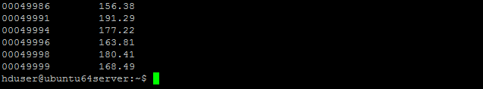

**Use case 2:**

To count all the transaction where amount is between 150 and 500. This use case also work with user interaction means it will work with the input given by the user and validation also successfully done here.

Taken input: 150 and 500

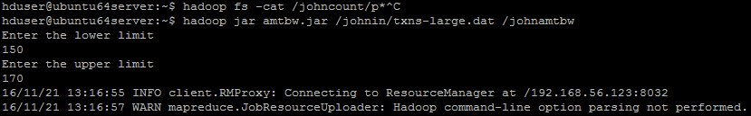

Expected output: 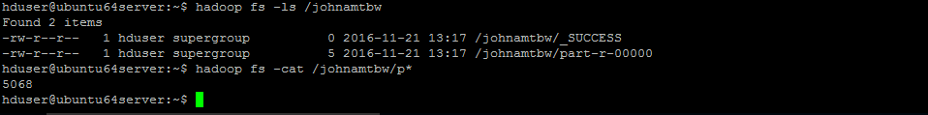

**Use case 3:**

Calculate the total sum and total count of all the transaction for each user id. This use case also work with user interaction means it will work with the input given by the user and validation also successfully done here.

Taken input:



Expected output:

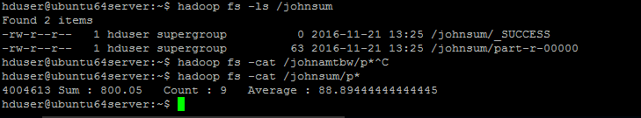

**Use case 4:**

Calculate total sales amount for each Month. This use case also work with user interaction means it will work with the input given by the user and validation also successfully done here.

Taken input:

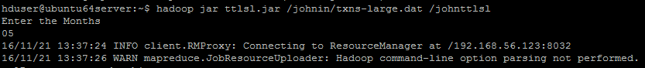

Expected output:

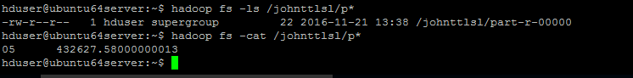

**Use case 5:**

Divide the file into 12 files, each file containing each month of data. For e.g. file 1 should contain data of January transaction, file 2 should contain data of February transaction. This use case also work with user interaction means it will work with the input given by the user and validation also successfully done here.

Taken input:

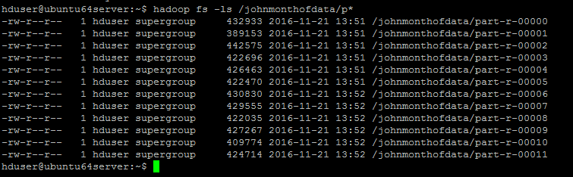

Expected output:

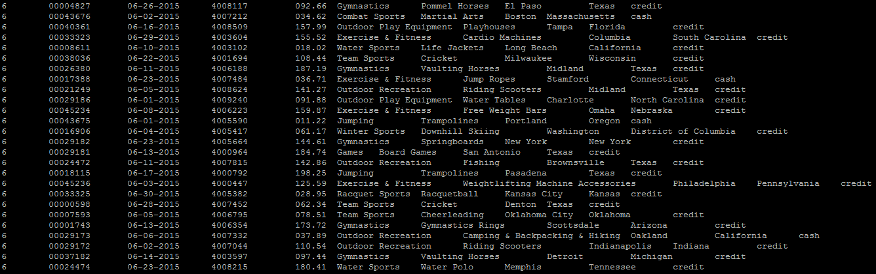

Use case 6:

Sorting all the transaction amount in ascending order.

Expected output:

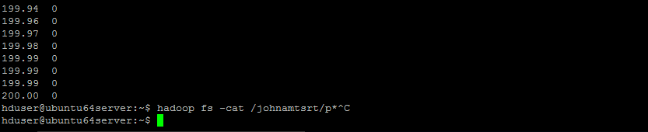

**Project through Hive**

**Use case 1:**

To get all the details from the transaction amount detail that is greater than with a specific amount which the user wants.

**Execution Query:**

select * from Ecom1 where amt>160;

**Use case 5:**

Count all the transaction where amount is between 175 to 200.

**Execution Query:**

select * from Ecom1 where amt between 175 and 200

**Use case 5:**

Calculate the total sum and total count and average of all the transaction for each user id.

**Execution Query:**

select uid,sum(amt),count(amt),avg(amt) from Ecom1 group by uid

**Use case 5:**

Find the name of user who has spend the maximum amount.

**Execution Query:**

select a.uid,SUM(a.amt) as Res,b.fname from ecom1 a join cust b on a.uid=b.uid group by a.uid,b.fname order by Res DESC limit 1;

**Use case 5:**

Find the name and product category for each user id and print in ascending order by product category.

**Execution Query:**

Select cust.fname, transaction.cat from cust inner join transaction on cust.id=transaction.id order by transaction .cat;

**Project through Pig**

**Use case 1:**

To get all the details from the transaction amount detail that is greater than with a specific amount which the user wants.

**Execution Script:**

a= load '/user/cloudera/Transactional.dat' using PigStorage(',');

b = foreach a generate $2,$3;

c = filter b by $1>160;

dump c;

store c into ‘/user/cloudera/task1’;

**Use case 2:**

Count all the transaction where amount is between 175 to 200.

**Execution Script:**

A = load '/user/cloudera/txns-large.dat' using PigStorage (',') as (tid, d, uid, amt : double , cat, prod,city,state,pt);

B = foreach A generate tid, amt;

C = filter B by ($1>170 and $1<200);

D = foreach C generate 1 as one;

E = group D by one;

F = foreach E generate COUNT(D.one);

dump F;

**Use case 3:**

Calculate the total sum and total count of all the transaction for each user id.

**Execution Script:**

step1 = load '/user/cloudera/txns-large.dat' using PigStorage(',');

step2 = foreach step1 generate $2 as uid,$3 as amt;

step3 = group step2 by uid;

step4 = foreach step3 generate group, SUM(step2.amt);

dump step4;

**Use case 4:**

Calculate the average transaction value for each user id.

**Execution Script:**

step1 = load '/user/cloudera/txns-large.dat' using PigStorage(',');

step2 = foreach step1 generate $2 as uid,$3 as amt;

step3 = group step2 by uid;

step4 = foreach step3 generate group, SUM(step2.amt),COUNT(step2.amt),AVG(step2.amt);

dump step4;

**Use case 5:**

Calculate total sales amt for each Month.

**Execution Script:**

a = load '/user/cloudera/txns-large.dat' using PigStorage(',') as (tid,tdate:chararray,uid,amt:double,cat,acc,city,state,pay);

b = foreach a generate SUBSTRING(tdate,0,2) as mon, amt;

c = group b by mon;

d = foreach c generate group, SUM(b.amt) as sum;

dump d;

**Use case 6:**

Divide the file into 12 files, each file containing each month of data. For eg. file1 should contain data of january txn, file 2 should contain data of feb txn.

**Execution Script:**

a = load '/user/cloudera/txns-large.dat' using PigStorage(',') as (tid,tdate:chararray,uid,amt:double,cat,acc,city,state,pay);;

b = foreach a generate SUBSTRING(tdate,0,2) as month,tid,tdate,uid,amt,cat,acc,city,state,pay;

c = filter b by month=='01';

dump c;

d = filter b by month=='02';

dump d;

e = filter b by month=='03';

dump e;

f = filter b by month=='04';

dump f;

g = filter b by month=='05';

dump g;

h = filter b by month=='06';

dump h;

i = filter b by month=='07';

dump i;

j = filter b by month=='08';

dump j;

k = filter b by month=='09';

dump k;

l = filter b by month=='10';

dump l;

m = filter b by month=='11';

dump m;

n = filter b by month=='12'; dump n;

**Use case 7:**

Find the name of top 3 spenders.

**Execution Script:**

a = load '/user/cloudera/txns-large.dat' using PigStorage(',') as (tid,tdate,uid:int,amt:double,cat,acc,city,state,pay);

b = load '/user/cloudera/custs-large.dat' using PigStorage(',') as

(uid:int,fname:chararray,lname,age,prof);

c = join a by uid,b by uid;

d = foreach c generate $2 as uid, $3 as amt,$10 as fname;

e = group d by (uid,fname);

f = foreach e generate group, SUM(d.amt) as Total;

g = order f by Total DESC;

h = limit g 3;

dump h;

**Use case 8:**

Find the profession of user who has spend the maximum amount.

**Execution Script:**

a = load '/user/cloudera/txns-large.dat' using PigStorage(',') as (tid,tdate,uid:int,amt:double,cat,acc,city,state,pay);

b = load '/user/cloudera/custs-large.dat' using PigStorage(',') as

(uid:int,fname:chararray,lname,age,prof:chararray);

c = join a by uid,b by uid;

d = foreach c generate $2 as ID,$3 as tamt,$13 as Prof;

f = group d by ($0,$2);

h = foreach f generate group,SUM(d.tamt) as Res;

i = order h by Res DESC;

j = limit i 1; dump j;

**Software and Hardware requirement**

* **Operating System :** Windows 7,8,10 and Mac.
* **Supporting software’s:** Ubuntu,putty, Oracle VM VirtualBox,WinSCP.
* **RAM :** Minimum 4GB.

**Conclusion**

With these different scenarios we can give different dimensional solution in accurate with a huge dataset. This type of data solution will help Industries to maintain their customer and transaction details as well. We are very trustable MNC for data solution and we can proudly say, we are the best data analyser and tech solution provider for other MNC`s and start-ups companies who needs data solution.